Version 0.0
september 20, 2017



Release Notes
Vessel visit and Service into Unit

Prepared for



Punta Caucedo, Boca Chica 15700, Dominican Republic

Table of Contents
1. Vessel visit and Service into Unit 3
2. Client Requirement 3
3. Scope 3
4. Configuration: 4
4.1. Add Code Extension: 4
4.2. Fields 5
4.3. Add General Notices 8
4.4. Groovy Code 9
5. Test Cases: 11
6. Screengrabs: 12

Vessel visit and Service into Unit
Enhancement to update vessel visit id and service on flexstring through record the specified UNIT_ACTIVATE against import/through/transship active/inbound unit by using general notices.

Client Requirement
- Update the vessel visit id and Service into unit

Scope
Create General Notices | : | Unit Update Flex Field
Create Code Extensions | : | DpwCauGvyUpdateFlexField

Configuration:

Add Code Extension:

DpwCauGvyUpdateFlexField

Scope Level : Facility
Scope : Current Scope
Extension Type : GENERAL_NOTICES_CODE_EXTENSION
Code Extension Name : DpwCauGvyUpdateFlexField
Extension Language : Groovy

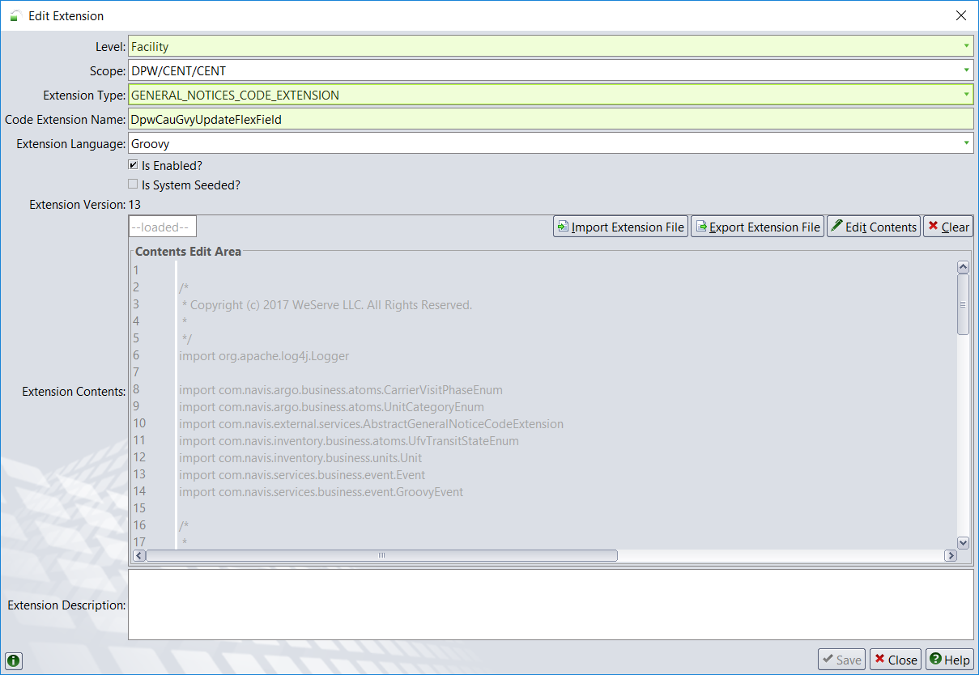

Fields
Administration → Settings → Fields
Override ‘ufvFelxString05’ as given below to update the I/B Carrier name details in unit level

Scope : Facility
Importance : Optional
Short Name : I/B Carrier name
Long Name : Inbound Carrier name
Group ID : 1-Unit

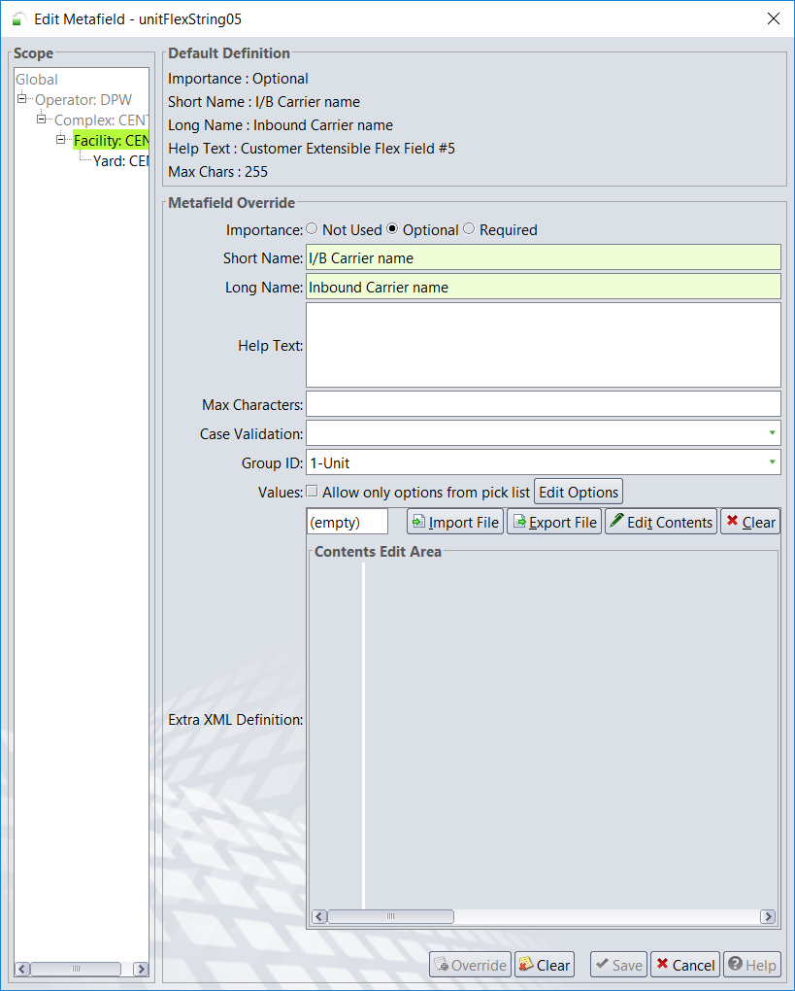

Administration → Settings → Fields
Override ‘ufvFelxString12’ as given below to update the Service details in unit level

Scope : Facility
Importance : Optional
Short Name : Service
Long Name : Service
Group ID : 1-Unit

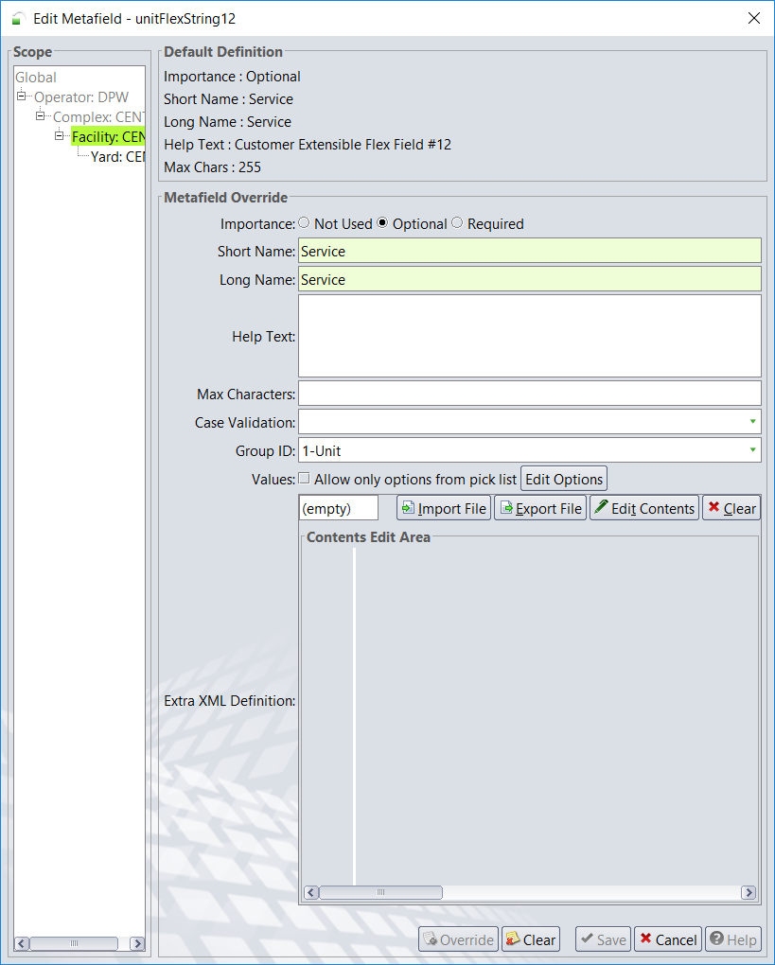

Notes:
- Rest the fields to get the changes done (Actions → Reset)
- Select ‘Propogate changes to all nodes’ option and click OK
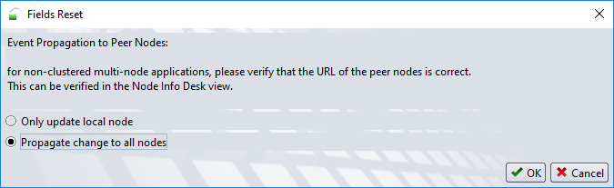

Add General Notices
Location: Operations →Reports →General Notices

Business Entity : UNIT
Description : Unit Update Flex Field
Event Type : UNIT_ACTIVATE
Action : Inbound Carrier name
Code Extension : DpwCauGvyUpdateFlexField

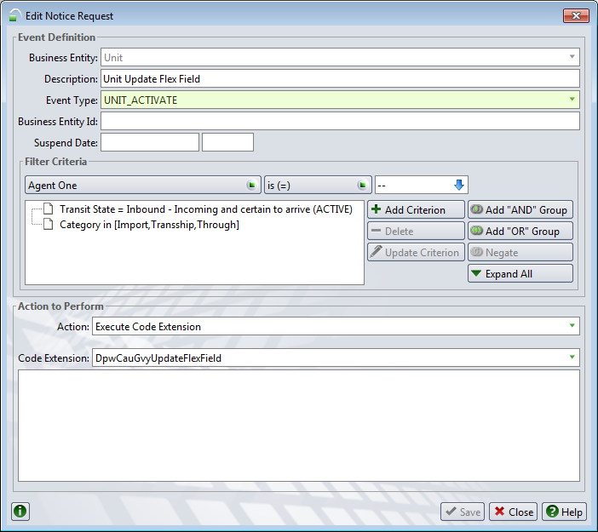

Groovy Code

/*
* Copyright (c) 2017 WeServe LLC. All Rights Reserved.
*
*/
import org.apache.log4j.Logger

import com.navis.argo.business.atoms.CarrierVisitPhaseEnum
import com.navis.argo.business.atoms.UnitCategoryEnum
import com.navis.external.services.AbstractGeneralNoticeCodeExtension
import com.navis.inventory.business.atoms.UfvTransitStateEnum
import com.navis.inventory.business.units.Unit
import com.navis.services.business.event.Event
import com.navis.services.business.event.GroovyEvent

/*
*
* @Author <a href="mailto:kgopinath@weservetech.com">Gopinath K</a>, 20/Sep/2017
*
* Requirements : This groovy is used to update the I/B Carrier Name and Service code to the Unit. While the UNIT_ACTIVATE event is recorded.
*
* @Inclusion Location : Incorporated as a code extension of the type GENERAL_NOTICE_CODE_EXTENSION as mention below.
*
* Deployment Steps:
* a) Administration -> System -> Code Extension
* b) Click on + (Add) Button
* c) Add as GENERAL_NOTICES_CODE_EXTENSION and code extension name as DpwCauGvyUpdateFlexField
* d) Paste the groovy code and click on save
*
* @Set up General Notice for event type "UNIT_ACTIVATE" on Unit Entity then execute this code extension (DpwCauGvyUpdateFlexField).
*
*/

class DpwCauGvyUpdateFlexField extends AbstractGeneralNoticeCodeExtension {
private static final Logger LOGGER = Logger.getLogger(DpwCauGvyUpdateFlexField.class);

public void execute(GroovyEvent inEvent) {
log("DpwCauGvyUpdateFlexField Execution Started")
long startTime = System.currentTimeMillis();
if (inEvent == null) {
return;
}
Event event = inEvent.getEvent();
if (event != null) {
Unit unit = (Unit) inEvent.getEntity();
if (unit != null && unitCategoryList.contains(unit.getUnitCategory()) && unit.getUnitActiveUfv() != null) {
if (UfvTransitStateEnum.S20_INBOUND.equals(unit.getUnitActiveUfv().getUfvTransitState())) {
if (unit.getInboundCv() != null && unit.getInboundCv().getCvCvd() != null && CarrierVisitPhaseEnum.INBOUND.equals(unit.getInboundCv().getCvVisitPhase())) {
unit.setUnitFlexString05(unit.getInboundCv().getCvId());
if ((unit.getInboundCv().getCvCvd() != null && unit.getInboundCv().getCvCvd().getCvdService() != null)) {
unit.setUnitFlexString12(unit.getInboundCv().getCvCvd().getCvdService().getSrvcId());
}
}
}
}
long endTime = System.currentTimeMillis();
log("DpwCauGvyUpdateFlexField Execution Completed in :" + (endTime - startTime) / 1000 + " secs.");
}
}

private static final List<UnitCategoryEnum> unitCategoryList = new ArrayList();
static {
unitCategoryList.add(UnitCategoryEnum.IMPORT);
unitCategoryList.add(UnitCategoryEnum.TRANSSHIP);
unitCategoryList.add(UnitCategoryEnum.THROUGH);
}
}

Test Cases:

S. No | Test Scenario | Steps to be performed | Expected Result
1 | Inbound Import unit Created through baplie when vessel visit in inbound phase | 1. Select a Vessel visit in inbound phase.  2. Load baplie with selected Vessel visit & containers with POD as current Port  3. Ensure units created are active / inbound | 1. unitFlexString05 is updated with Vessel visit id.  2. unitFlexString12 is updated with Service ID of the Vessel Visit
2 | Inbound tranship unit Created through baplie when vessel visit in inbound phase | 1. Select a Vessel visit in inbound phase.  2. Load baplie with selected Vessel visit & container with POD as next port and o/b carrier as 'GEN_VESSEL'  3. Ensure units created are active / inbound | 1. unitFlexString05 is updated with Vessel visit id.  2. unitFlexString12 is updated with Service ID of the Vessel Visit
3 | Inbound through unit Created through baplie when vessel visit in inbound phase | 1. Select a Vessel visit in inbound phase.  2. Load baplie with selected Vessel visit & & container with POD as next port and o/b carrier as same vessel visit ID  3. Ensure units created are active / inbound | 1. unitFlexString05 is updated with Vessel visit id.  2. unitFlexString12 is updated with Service ID of the Vessel Visit
4 | Updating advised unit to active inbound | 1. Select a Vessel visit in created phase.  2. Select advised units having i/B Actual Visit as the selected vessel visit ID  2. Advance the Vessel visit in to inbound phase.  3. Ensure units are active / inbound | 1. unitFlexString05 is updated with Vessel visit id.  2. unitFlexString12 is updated with Service ID of the Vessel Visit
5 | Inbound unit updated through baplie & vessel visit in inbound phase | 1. Select a Vessel visit in inbound phase.  2. Select inbound units having i/B Actual Visit as the vessel visit ID and flexString values as empty(null)  3. Load baplie with selected Vessel visit & selected units. | 1. unitFlexString05 & 2. unitFlexString12 are not updated with Vessel visit id and Service ID
6 | Advised unit Created through baplie when vessel visit in inbound phase | 1. Select a Vessel visit in inbound phase.  2. Load baplie with selected Vessel visit.  3. Ensure units created are advised / advised | 1. unitFlexString05 & 2. unitFlexString12 are not updated with Vessel visit id and Service ID
7 | Advised unit Created through baplie when vessel visit in created phase | 1. Select a Vessel visit in created phase.  2. Load baplie with selected Vessel visit.  3. Ensure units created are advised / advised | 1. unitFlexString05 & 2. unitFlexString12 are not updated with Vessel visit id and Service ID
8 | Inbound unit Created through baplie when vessel visit in working phase | 1. Select a Vessel visit in working phase.  2. Load baplie with selected Vessel visit.  3. Ensure units created are active / inbound | 1. unitFlexString05 is not updated with Vessel visit id.  2. unitFlexString12 is not updated with Service ID of the Vessel Visit

Screengrabs:

Updation of Vessel Visit and Service into unit

